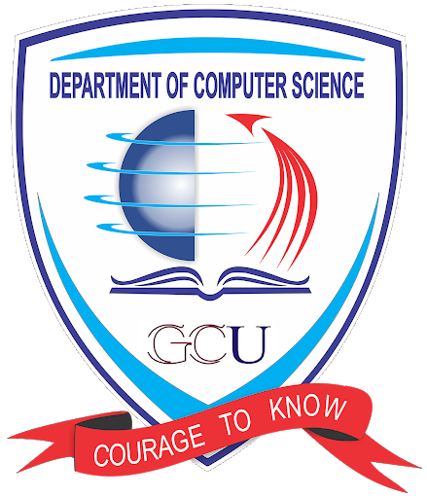

**CS-2105**

**Software Engineering**

**Project’s Proposal**

#### **Department of Computer Science,**

**GC University Lahore**

**Submitted by: -**

**Iqra Khalique**

**Zarafshan Arjumand**

**Ayesha Yousaf**

**Section: CS-A2**

**Semester: 5th**

**Project’s Title:**

*Online Bank Management System*

**Project’s Proposal:**

*This system would allow user to create an account and through that it can login. For security purposes, it requires your verified government documents. After all this, you can deposit and withdraw money. Moreover, you can send and receive money from other users as well. Further facilities includes taking loan ,funding any organization ,donation ,loan management and paying utility bills etc.*

**Different approaches on the selected proposal:**

***Waterfall model:***

We cannot apply this model on our proposal because it falls in the category of medium to large scale project. Moreover, the client seems unsure of the requirements as he has used *'etc'* in the given proposal. Also, there is no testing phase in each development stage, because of this, the debugging phase at the end may get very messy as we have not tested the project in each respective phase.

***V-model:***

We cannot apply this model because it is the extension of the Waterfall model, the issues prevalent in the Waterfall model persist with this model as well. It *'solves'* one problem by introducing a testing phase. The issue lies in the fact that we cannot test the entire project in one go. Errors will arise and in V-model, we can only test the project, not fix any major errors. So, there are could be lot of error leading to failure.

***Incremental Model:***

We can apply Incremental model on this project because we can divide the project in different increments. For example, the first increment could have user authorization, user registration and user login. The second increment includes transaction history, transaction log, transactions, loan taking, loan management. The third increment can handle utility bills payment, funding any organization and donations. Subsequent fourth and fifth increments could focus on services demanded by the client and updates. This model carries low risk and failure rate. It has user feedback which will in each increment which will guarantee success.

***Prototype Model:***

We can also apply prototype model because it would have user feedback which will guarantee success in each increment. First, we will develop an initial prototype with basic feature and present it to the stakeholders. After gathering their feedback, we would apply that information into our model and make it more user friendly.

***Spiral Model:***

For security purposes of banking system, it would be more suitable to use the spiral model. This model emphasizes risk assessment and iterative development. It would enhance the protocol according to modern needs, demands and requirements.

***XP model:***

We can also apply this model, because things are going to be more detailed and practical. It would be based on experienced people which would give fruitful results. After reanalyzing, reassessing user stories we can change internal structure. It would improve the product's overall look and functionality. We can apply this model when our team is experienced, this is the only major drawback.

***Scrum model:***

This model signifies a leader role in the project’s completion. It values an internee as well as an experienced engineer. This approach could be applied in a software house where we need to teach internees how to practically deal with things. It would have daily meeting on the project. On a surface level, this approach is best as it would give space to the team member lead them to accelerate but also demand the answers from them.

***Conclusion:***

We are going with the agile/XP process model because it values customer satisfaction over contract documentation and prefers change over rigid plans. Moreover, it is going to help as we are going to make CRC which is going to make it more refine and we are actually converting user stories into reality which is eventually leading to customer validation and satisfaction. It has all the good things of prototype model. It will allow continuous testing and integration.